**JAWAHARLAL NEHRU UNIVERSITY**

**Project Report**

**ON**

**ALLEVIATE HUNGER**

**(A web-based Project)**

**Under the guidance of**

**Prof. Karan Singh**

**Submitted by: Group 2**

**Tarana Shahin(18/10/JC/016)**

**Anjali(18/10/JC/017)**

**Shashank Gupta(18/10/JC/015)**

**(MCA 4th Semester)**

**Table of Content**

|  |  |  |
| --- | --- | --- |
| S.No | Topic | Page no |
| 1. | Acknowledgement | 3 |
| 2. | Introduction | 4 |
| 3. | Motivation | 5 |
| 4. | Challenges | 5 |
| 5. | Application | 6 |
| 6. | Objective | 6 |
| 7. | Methodology | 6 |
| 8. | Requirements | 7 |
| 9. | Problem Statement | 8 |
| 10. | Proposed Project | 8 |
| 11. | About | 8 |
| 12. | ER Diagram | 9 |
| 13. | Data flow Diagram | 10 |
| 14. | Database Tables | 13 |
| 15. | Modules | 19 |
| 16. | Module wise Snaps | 20 |
| 17. | Source code | 26 |
| 18. | Market Analysis | 28 |
| 19. | Novelty | 28 |
| 20. | Implementation | 29 |
| 21. | Conclusion | 30 |
| 22. | Appendix | 31 |
| 23. | Reference | 33 |
| 24. | User Manual | 34 |
| 25. | Developer Manual | 37 |

**Acknowledgement**

For this project we would like to thank Professor Karan Singh sir who has been guiding us throughout the journey of making this project. Without their effort and guidance, it would have not been possible to make this much of effort in this project. As we were in lockdown still giving us the live sessions to help us to complete this project. And that was very helpful and always keep us motivated to complete this project.

Thanking you!!

**INTRODUCTION**

Alleviate Hunger- A web based social service project, as its name might suggest, is a social web application designed to provide the necessary information for people to take the initiative and support each other. This application allows its users to search based on their location for the nearest people who are in need of food and help them by providing food.

On the other hand, it also allows other people to share information about their needs and ask for help in a modern and less embarrassing way.

This software will make it easier for anyone to donate food in a simple and the least troubling way, because it shows the nearest location where people are in need of food.

Some might ask, if a person is actually in need, they won’t have access to the modern technologies. My answer to that is that anyone can create a profile for these people, by simply provide their location and their contacts. Again, this might not be the case for some families; however, this project is designed to help those who can’t help themselves, and also get people to take the initiative, by either donating food or money for people they know who might need help.

Our project developed with the help of PHP, HTML, JavaScript, CSS and Bootstrap. For the database we have used MySQL and used Xampp to run it in local server that is Apache sever.

**MOTIVATION**

Feeding India that is an existing website, we have taken motivation from there whose main objective is to alleviate hunger founded by Ankit Kawatra.

Also, in today’s situation of pandemic where everything is under lockdown, it is impossible to go outside and earn. We can see there are many people who became jobless and homeless in this time and of course, they are left with nothing, not even food. So we also took motivation from this situation where people who want to help the needy ones can help them by providing food or money and that too from their comfortable locations. So, this application will act as an intermediate between those who want to help and those who need help.

**CHALLENGES**

1.First challenge that we faced was to design a good database so that we don't have redundant values in the database. Normalization of the database.

2. Deciding the home page layout, in this we tried two to three layouts to finalize the one

3. Proper usage of PHP so that we can achieve what we really wanted from the website.

4.Flow of data into the database and user and admin

5.Designing the layout that suits the website.

**APPLICATIONS**

1.Provides a platform between the people who have surplus amount of money and the people who are in need of food.

2. Helping to remove hunger so that no one can sleep hungry.

3. Helping everyone with food in this situation of pandemic.

4. There is no risk of data mismanagement at any level while project development is under process.

5. Provides high level of security with different level of of authentication

**OBJECTIVE**

Alleviate Hunger will be a non-profit web-based project solving the problem of hunger, food waste and malnutrition. About 67 million tons of food is wasted in India annually valued at Rs.920 billion. So, our objective is to make such a platform where we can solve this problem of hunger and malnutrition by providing food to the needy.

**METHODOLOGY**

We will be using Spiral model. **Spiral model** is one of the most important Software Development Life Cycle models, which provides support for **Risk Handling**. In its diagrammatic representation, it looks like a spiral with many loops. The exact number of loops of the spiral is unknown and can vary from project to project. **Each loop of the spiral is called a Phase of the software development process.** The exact number of phases needed to develop the product can be varied by the project manager depending upon the project risks. As the project manager dynamically determines the number of phases, so the project manager has an important role to develop a product using spiral model.

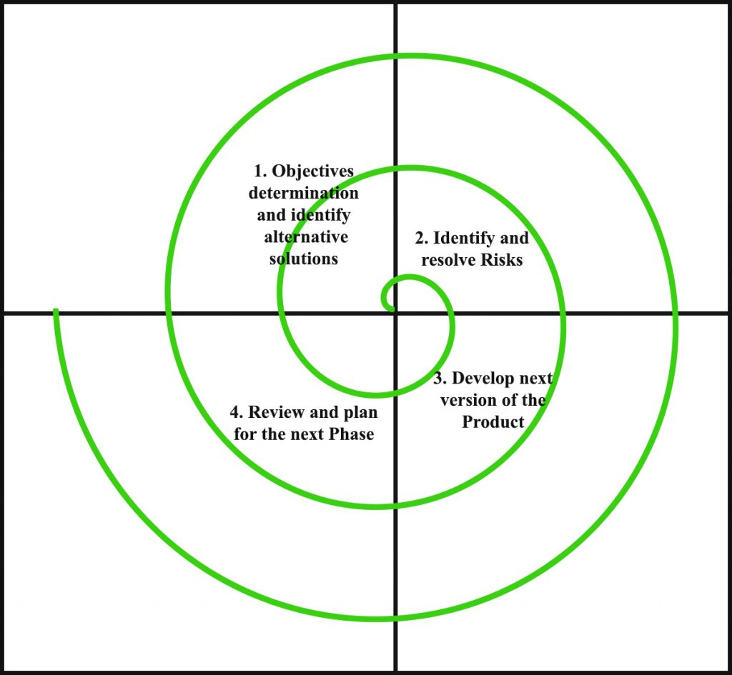

**REQUIREMENTS**

* **Software Requirement Specifications**

Language Used                  :                       JavaScript

Database                            :                       My SQL

User Interface Design        :                       HTML, CSS

Web Browser                     :                       Mozilla, Google Chrome

* **Hardware Requirement Specifications**

Monitor                            :                       Color Monitor

Hard disk                         :                       40 GB

RAM                               :                       1 GB

Processor                         :                       Pentium IV

Keyboard                         :                       104 Keys

Operating System            :                       Windows 7,8,10

**PROBLEM STATEMENT**

This web-based project aims to solve the problem of hunger so that nobody should sleep hungry. The project aims to create an online platform where the user who has surplus amount of food can donate and needy people can request for food. Those who want to volunteer can also volunteer.

**PROPOSED PROJECT**

The Proposed web application Alleviate Hunger is internet-based application that provides a platform for donating food to all needy people/organizations. The product is shown to be an effective means of donating food to organizations and needy people over the internet.

The product is an internet-based website application that basically aims food donation. Many people, institutes wish to donate food to needy organizations. Thereby, an web based application has been developed through which people can donate food items as per their capacity and the application also allows organizations and needy ones to put up their requests.

**ABOUT**

Alleviate Hunger- A web based social service project, as its name might suggest, is a social web application designed to provide the necessary information for people to take the initiative and support each other. This application allows its users to search based on their location for the nearest people who are in need of food and help them by providing food.

**ER DIAGRAM**

An ER diagram shows the relationship among entity sets. An entity set is a group of similar entities and these entities can have attributes. In terms of DBMS, an entity is a table or attribute of a table in database, so by showing relationship among tables and their attributes, ER diagram shows the complete logical structure of a database. Let’s have a look at a simple ER diagram to understand this concept.

Symbols used in ER diagram:

**ER DIAGRAM**

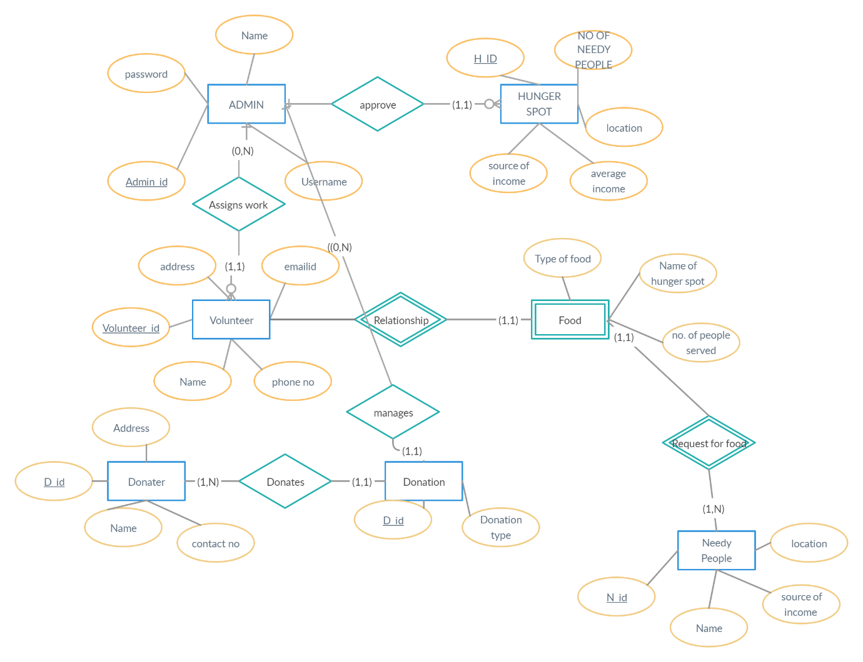

**DATA FLOW DIAGRAM**

A Data Flow Diagram (DFD) is a traditional way to visualize the information flows within a system. A neat and clear DFD can depict a good amount of the system requirements graphically. It can be manual, automated, or a combination of both.

It shows how information enters and leaves the system, what changes the information and where information is stored. The purpose of a DFD is to show the scope and boundaries of a system as a whole. It may be used as a communications tool between a systems analyst and any person who plays a part in the system that acts as the starting point for redesigning a system.

The symbols used in a DFD are as follows:



**0-LEVEL DFD :**

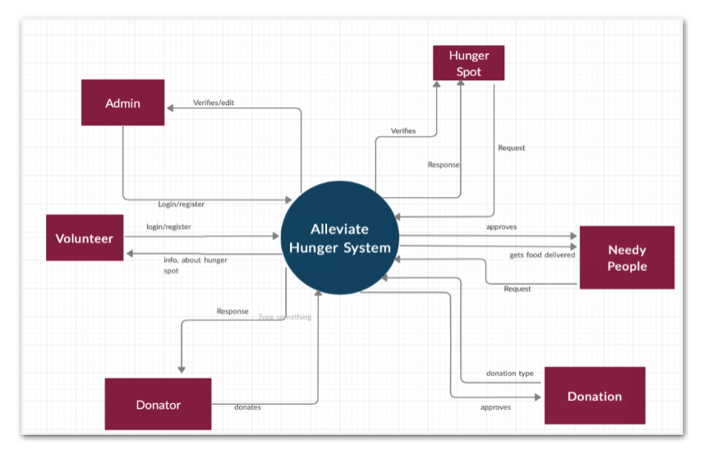

**1-LEVEL DFD:**

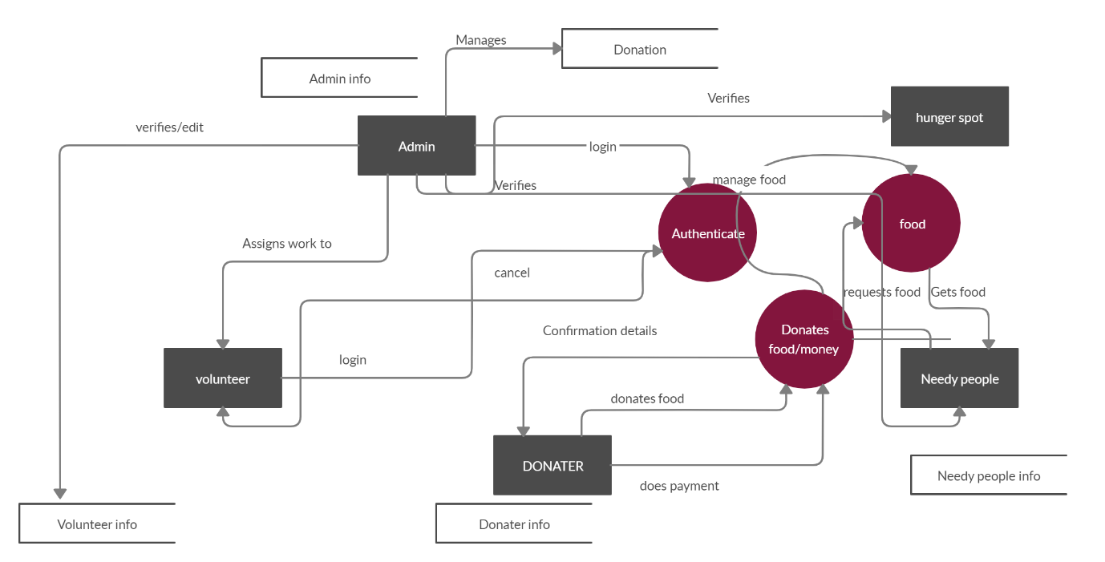

**DATABASE TABLES :**

1. **User Table**

| Attribute | Data type | Description |
| --- | --- | --- |
| Userid | int | Auto incremented id for each user that is added to the table in the database |
| FirstName | varchar | First name of the user |
| LastName | varchar | Last name of the user |
| MiddleName | varchar | Middle name of the user |
| username | varchar | The user name of the user. |
| password | varchar | The password that is set by the user to be able to access his/her profile. |
| ContactNo | int | Phone number of the user |
| Email | varchar | Email id of the use which has to be unique |
| GenderId | int | Id which depicts the gender go the user |
| RoleId | int | Role id tells about the role whether user is a volunteer or donor. |

**2. Volunteer Availability Table**

| Attribute | Data Type | Description |
| --- | --- | --- |
| UserId | int | Auto incremented id for each user that is added to the table in the database |
| StartTime | int | Starting time at which the volunteer will start volunteering |
| EndTime | int | Ending time at which volunteer will stop volunteering |
| Date | int | Date on which the volunteer is available |

**3. Address Table**

| Attribute | Data Type | Description |
| --- | --- | --- |
| UserId | int | Auto incremented id for each user that is added to the table in the database |
| DonationFoodId | int | Id for donation food |
| RequestFoodId | Int | Id for request food |
| Street | varchar | Street no.of the user |
| City | varchar | City of the user |
| Landmark | varchar | Landmark of the location of the user |
| State | varchar | State of the user |
| Pincode | Int | City of the user |
| Country | varchar | Coof the user |

**4. Food Donation Status Table**

| Attribute | Data Type | Description |
| --- | --- | --- |
| FoodDonationStatusId | Int | Auto incremented id for each donation status that is added to the table in the database |
| Status | varchar | Status of the donation whether donation is completed or on process. |

**5. Delivery Status Table**

| Attribute | Data Type | Description |
| --- | --- | --- |
| DeliveryStatusId | Int | Auto incremented id for each delivery status that is added to the table in the database |
| Status | varchar | Status of the food delivery whether donation is completed or on process. |

**6. Donation Money Table**

| Attribute | Data Type | Description |
| --- | --- | --- |
| DonationMoneyId | int | Auto incremented id for each donation that is added to the table in the database |
| UserId | int | UserId of the donor |
| ContactDetail | int | Contact Details of the Donor |
| EmailId | int | EmailId of the donor. |
| Amount | int | Amount payable by the donor. |

**7. Food Type Table**

| Attribute | Data Type | Description |
| --- | --- | --- |
| Fid | Int | Auto incremented id for food type that is added to the table in the database |
| Type | varchar | Type of food whether food is prepared or raw. |

**8. Donation Food Table**

| Attribute | Data Type | Description |
| --- | --- | --- |
| DonationFoodId | int | Auto incremented id for each donation that is added to the table in the database |
| UserId | int | UserId of the donor |
| FoodTypeId | int | Determines type of food for donation |
| AmountOfFood | int | Amount of food for donation |
| NumberOfMeals | int | Number of meals for donation |
| IsPermanenetAddress | int | Check the address |
| Status | int | Determine the status of the donation |

**9. Gender Table**

| Attribute | Data Type | Description |
| --- | --- | --- |
| Genderid | Int | Id which determines the gender of the user |
| Gender | varchar | Gender of the user |

**10. Request Food Table**

| Attribute | Data Type | Description |
| --- | --- | --- |
| NeedyPeopleId | int | Id for needy people |
| RequestId | int | Id which determines the request and type of request |
| NumberOfMeals | int | Number of meals requested |
| AmountOfFood | int | Amount of food requested |
| IsPermanenetAddress | int | Check the address |
| DeliveryStatusId | int | Determine the status of the delivery of request |

**MODULES**

The project will have following modules:

**1.HOME PAGE:** The home will contain all the functionality of the project that will be shown in menu. This will be the first page of our website. Whenever a person opens up this website this page will be the first page, he/she will see. On this page there are various options given in the menu bar where the user can donate food/money, request for food, assign a place to hunger spot and volunteer.

**2.LOGIN/REGISTER MODULE:** Login and Register module allows anybody to login into the system and do the appropriate tasks. Whenever a person register himself all his data will be saved in the database and that data is used to verify the user at the time of login. A user can register as a Donor, Volunteer or Needy.

**3. Admin Module:** This module will be accessible the Admin of the website only. This module is going to be confidential because an admin can handle and maintain the system and it is the responsibility of the admin to secure the data of the user. Admin can allow the user to register, login and to perform all the available tasks in project by handling the database.

**4**.**Donate Food**: Where a person can donate food by filing up a form where he/she has to provide some necessary details and have to sign up. After signup the user is allow to donate food. The food can be raw food or prepared food.

**5.Donate Funds**: A person can support the work by providing a fund with whatever he/she is willing to. The payments done by the user will be through an online payment gateway through cards or by using net banking and wallets.

**6.Volunteer**: Those who want to become a part of the program can volunteer by filing up an online form. The task of the volunteer is the delivery of the food. The volunteer has to deliver the food to the needy people. Volunteer also have to pick up the food the donor’s location.

**7.Request for Food:** Here needy people who are in need of food can register in our website and get the food delivered at his/her doorstep.

**MODULE WISE SNAPS:**

**Home page: -**

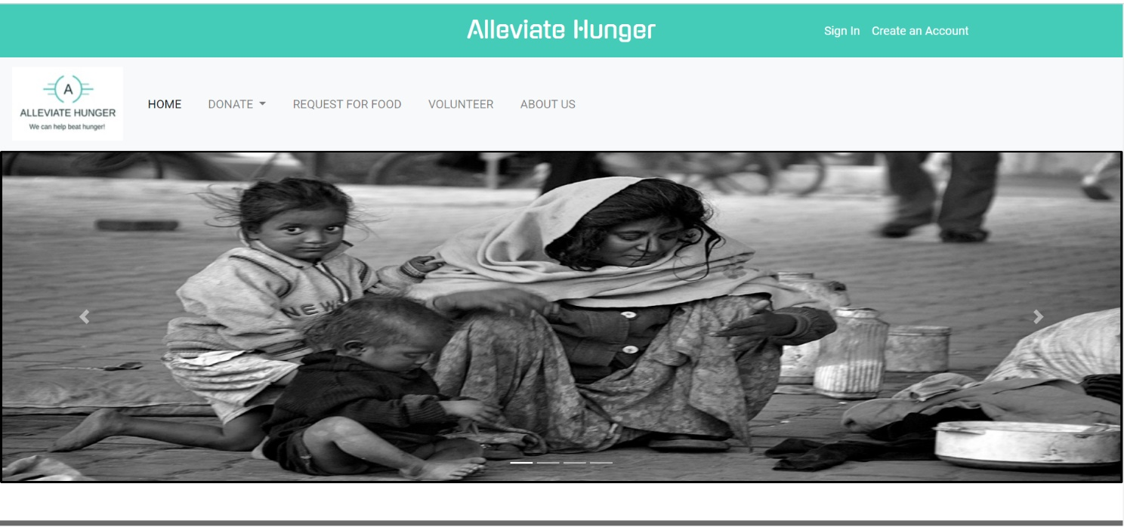

**Login page: -**

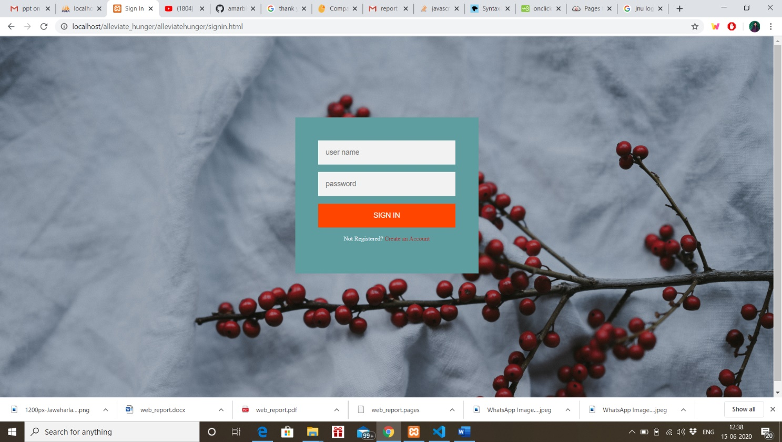

**Registration page: -**

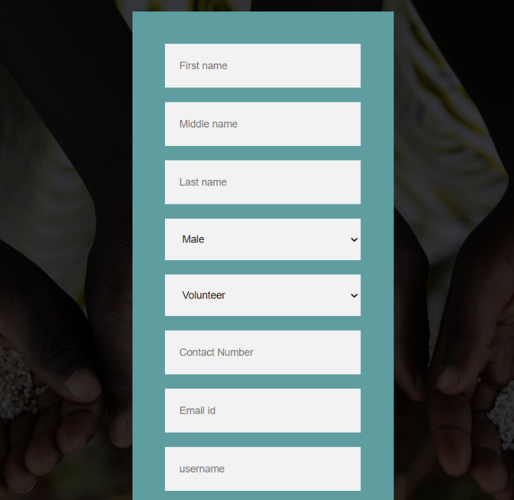

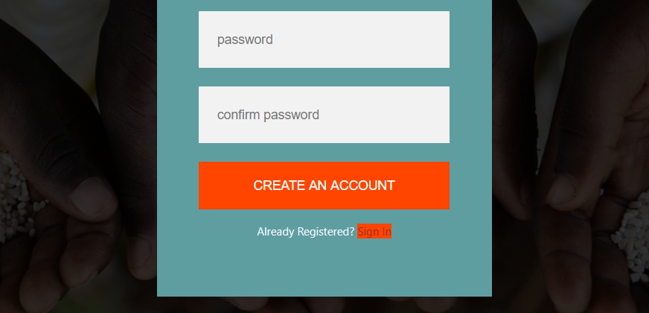

**Donate Food: -**

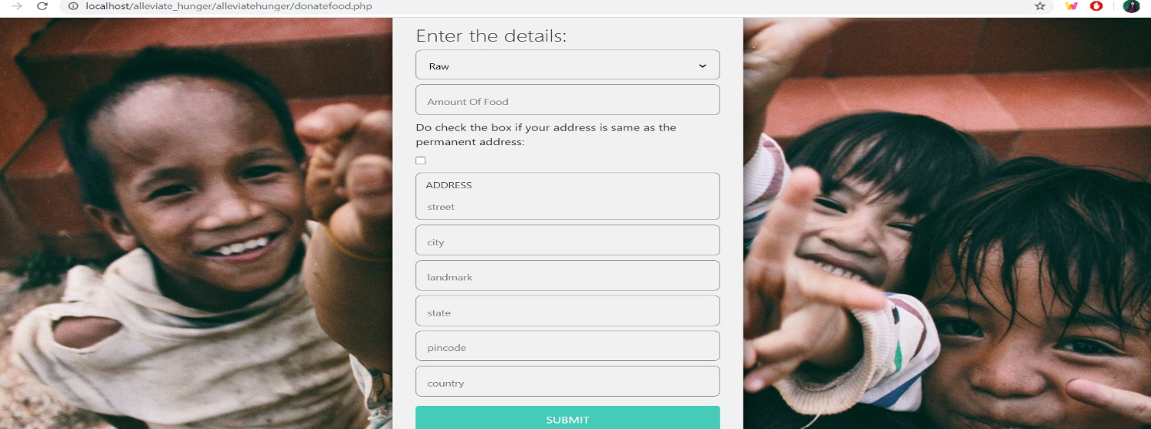

**Donate Funds: -**

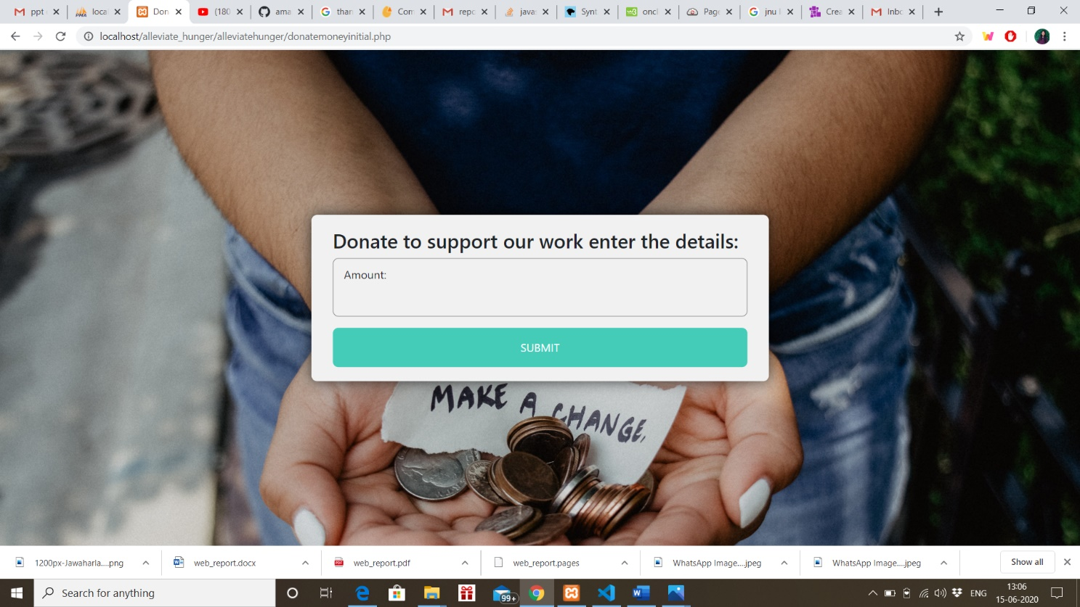

**Payment portal: -**

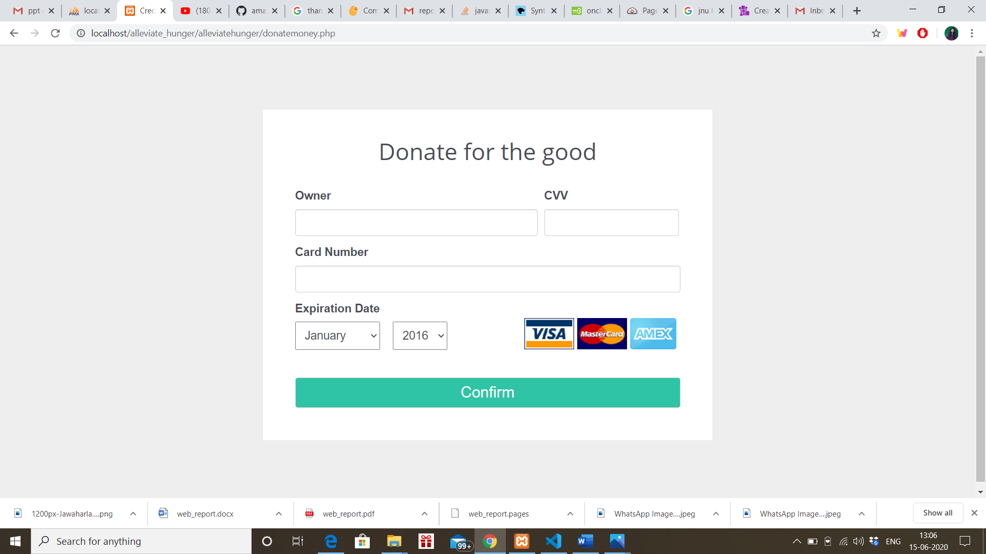

**Volunteer: -**

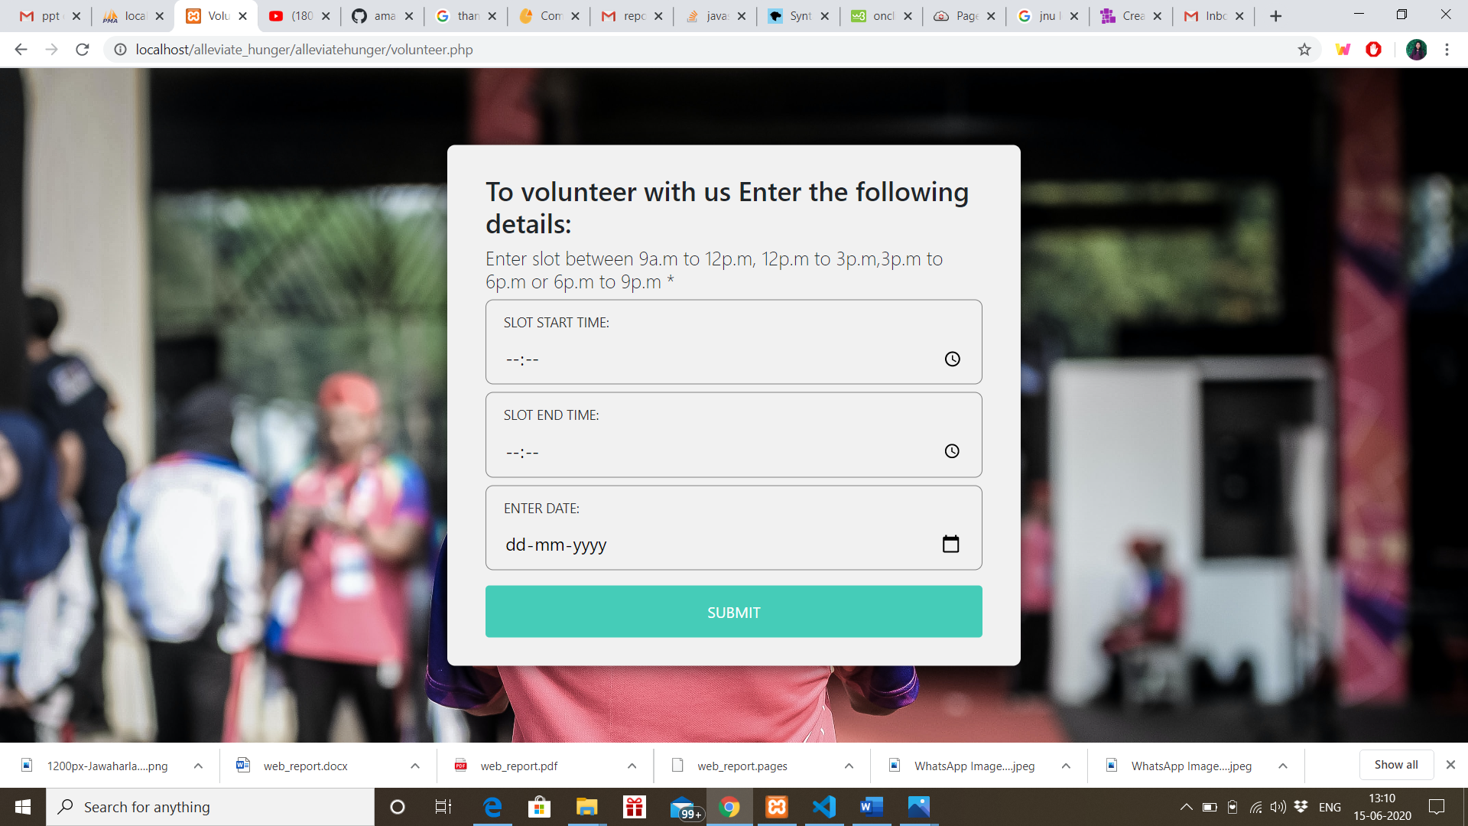

**Request for Food: -**

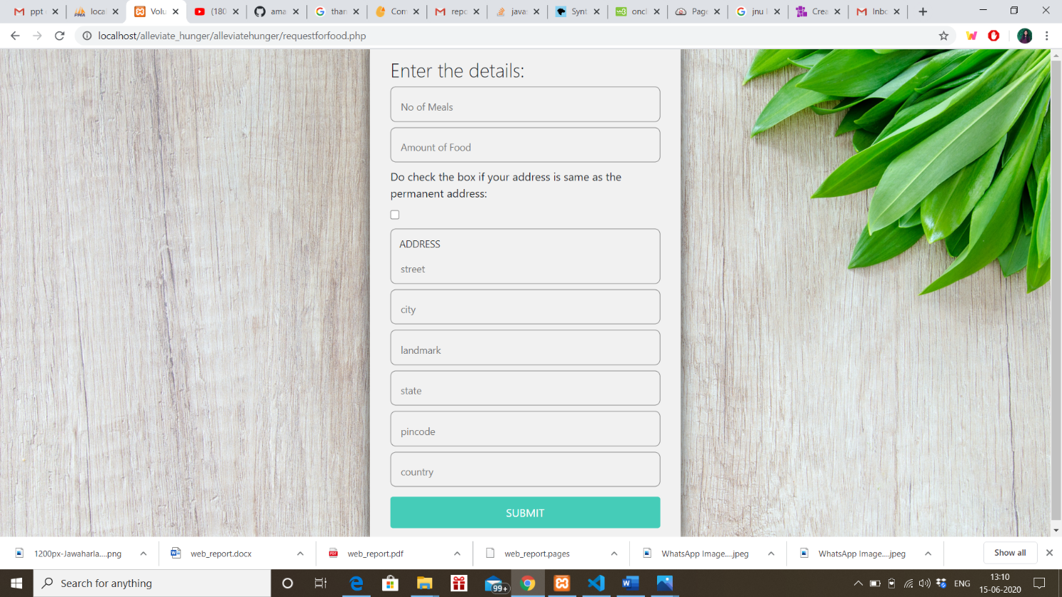

**Profile of user: -**

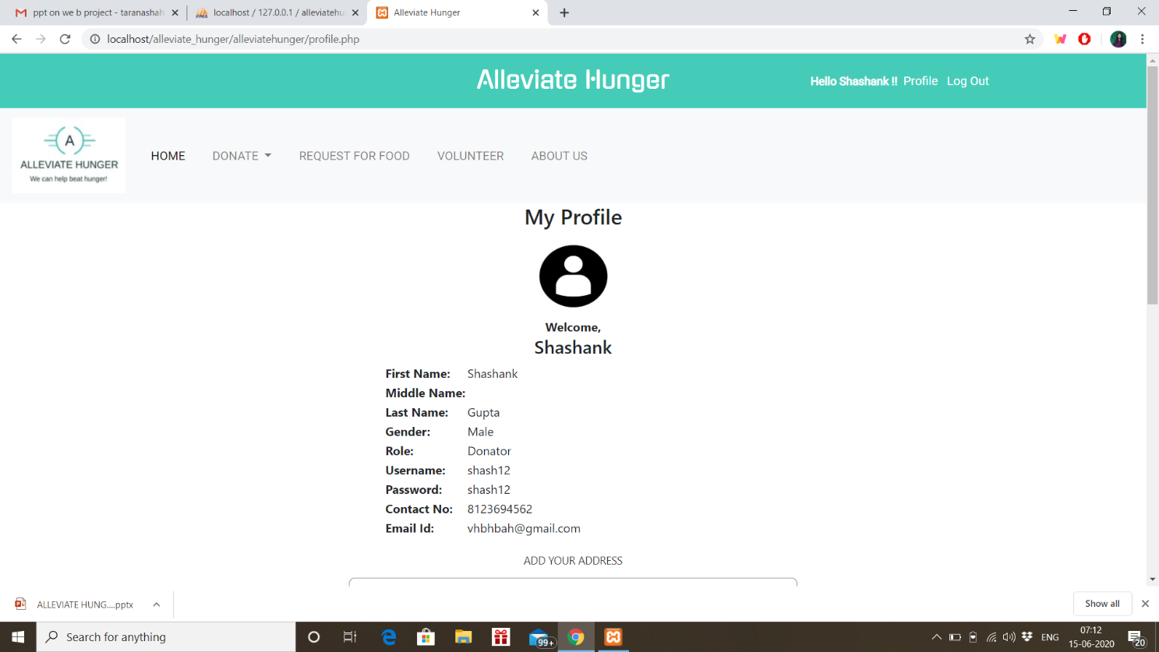

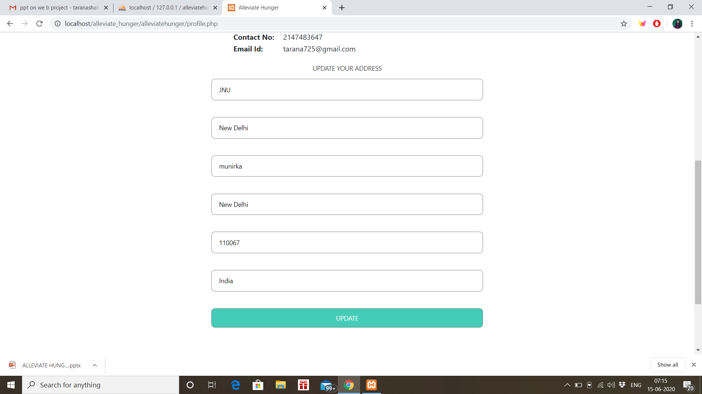

**Admin Panel: -**

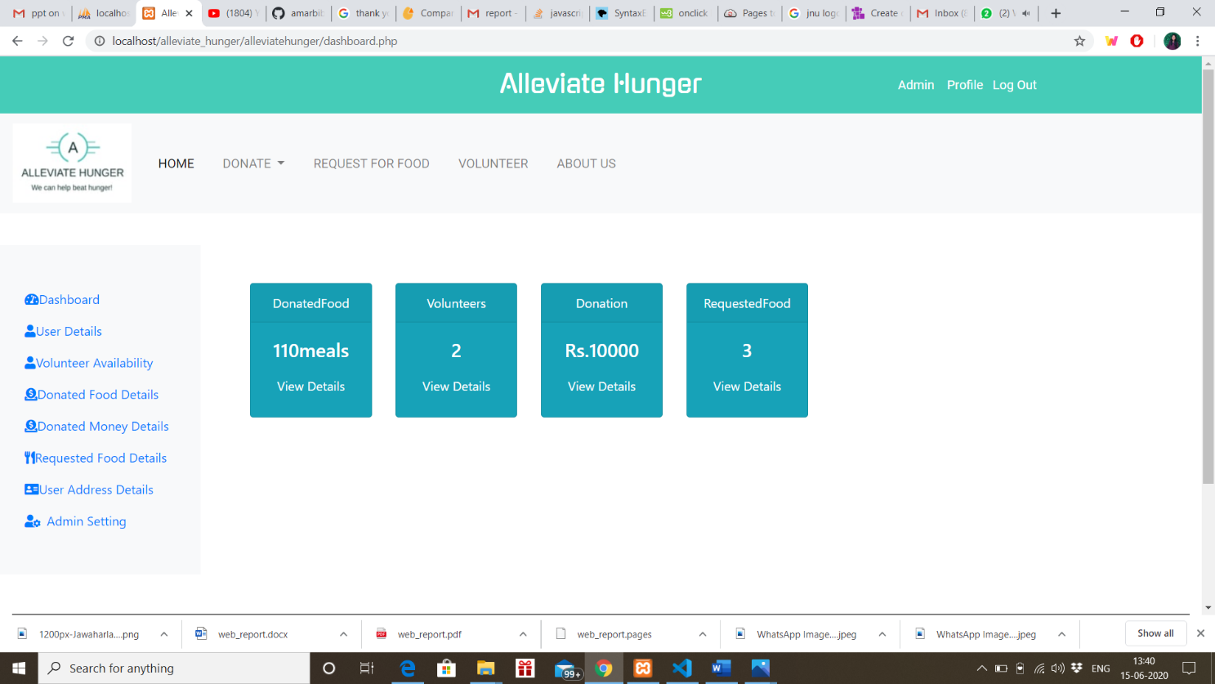

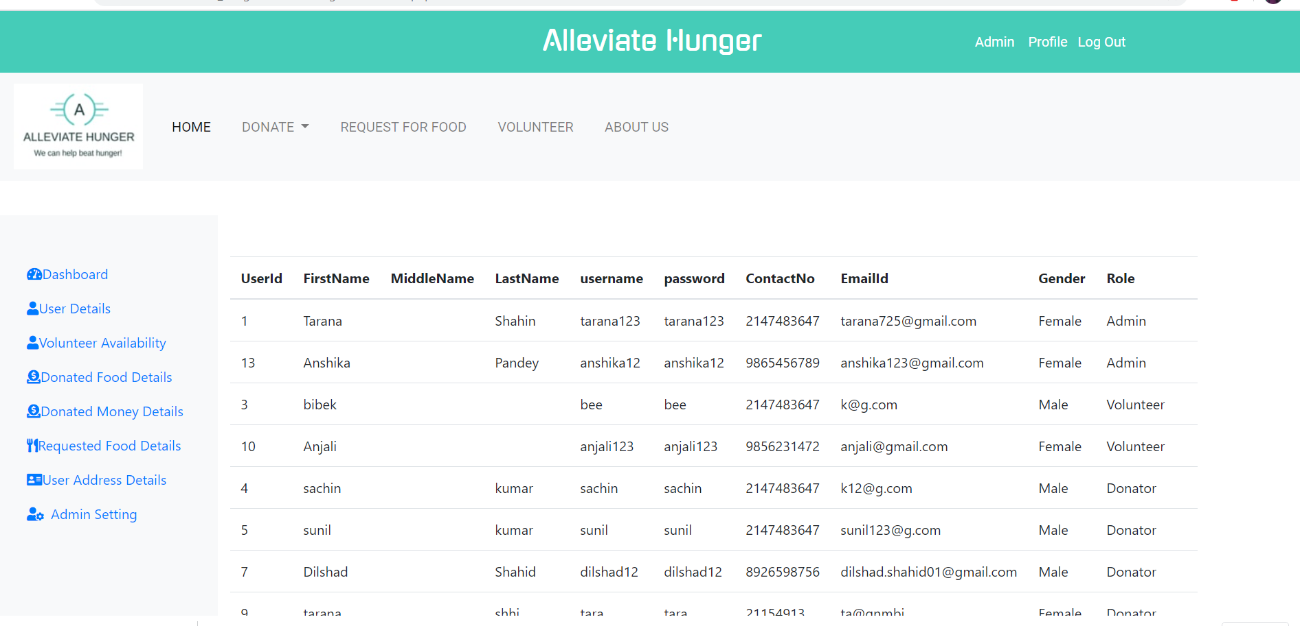

**Some of the source codes: -**

* To establish connection with the database:

<?php

$conn = new mysqli("localhost", "root", "");

if ($conn->connect_error) {

    echo "connection error";

    die("Connection failed: " . $conn->connect_error);

}

mysqli_select_db($conn, 'alleviatehunger' );

* The source code for slider of the home page: -

<div id="slider">

      <div id="headerSlider" class="carousel slide" data-ride="carousel">

        <ol class="carousel-indicators">

          <li data-target="#headerSlider" data-slide-to="0" class="active"></li>

          <li data-target="#headerSlider" data-slide-to="1"></li>

          <li data-target="#headerSlider" data-slide-to="2"></li>

          <li data-target="#headerSlider" data-slide-to="3"></li>

          <!-- <li data-target="#headerSlider" data-slide-to="4"></li> -->

        </ol>

        <div class="carousel-inner">

          <div class="carousel-item active">

            <img src="images/img3.jpg" class="d-block w-100" id="image" >

          </div>

          <div class="carousel-item">

            <img src="images/img1.jpg" class="d-block w-100" id="image">

          </div>

          <div class="carousel-item">

            <img src="images/img4.jpg" class="d-block w-100" id="image">

          </div>

          <div class="carousel-item">

            <img src="images/img5.png" class="d-block w-100" id="image">

          </div>

          <!-- <div class="carousel-item">

          <img src="images/img5.png" class="d-block w-100" id="image">

        </div> -->

      </div>

      <a class="carousel-control-prev" href="#headerSlider" role="button" data-slide="prev">

        <span class="carousel-control-prev-icon" aria-hidden="true"></span>

        <span class="sr-only">Previous</span>

      </a>

      <a class="carousel-control-next" href="#headerSlider" role="button" data-slide="next">

        <span class="carousel-control-next-icon" aria-hidden="true"></span>

        <span class="sr-only">Next</span>

      </a>

    </div>

  </div>

// We made the slider using the carousel class of the bootstrap.

This slider containing images having backward and forward direction.

* Login/Register form

<html>

<head>

    <title>Sign In</title>

    <link rel="stylesheet" href="./css/signin.css">

</head>

<body>

  <div class="login-page">

  <div class="form">

    <form class="register-form">

    <input type="text" placeholder="First name"/>

  <input type="text" placeholder="Middle name"/>

    <input type="text" placeholder="Last name"/>

  <input type="text" placeholder="Gender"/>

  <input type="text" placeholder="Role"/>

  <input type="text" placeholder="Contact Number"/>

    <input type="text" placeholder="Email id"/>

    <input type="text" placeholder="user name"/>

    <input type="text" placeholder="password"/>

    <button>Create an Account</button>

    <p class="message"> Already Registered? <a href="#">Sign In</a>

    </p>

    </form>

    <form class="login-form" action="signin_insert.php" method="POST">

    <input type="text" name="username" placeholder="user name"/>

    <input type="password"  name="password" placeholder="password"/>

    <button type="submit">Sign In</button>

    <p class="message">Not Registered? <a href="#">Create an Account</a></p>

    </form>

  </div>

  </div>

  <script src='https://code.jquery.com/jquery-3.5.0.min.js'>

  </script>

  <script>

  $('.message a').click(function(){

  $('form').animate({height: "toggle", opacity: "toggle"}, "slow");

  });

  </script>

</body>

</html>

This is a simple sign in/register form made by html and JavaScript for toggling between register/sign in.

**Note: - Rest source code has been attached as a zip file.**

**MARKET ANALYSIS**

Basically, it’s a non-profit social service-based project to help the people who are in need of food. So, this is not made to make profit rather than helping poor to alleviate hunger.

**NOVELITY**

Since our project is just a prototype and meets the necessary requirements hence as of now it has no novelty but it has a scope and we are trying to add some new features in the project for example hunger spot, feedback etc.

**IMPLEMENTATION**

XAMPP is a [free and open-source](https://en.wikipedia.org/wiki/Free_and_open-source) [cross-platform](https://en.wikipedia.org/wiki/Cross-platform) [web server](https://en.wikipedia.org/wiki/Web_server) [solution stack](https://en.wikipedia.org/wiki/Solution_stack) package developed by Apache Friends,consisting mainly of the [Apache HTTP Server](https://en.wikipedia.org/wiki/Apache_HTTP_Server), [MariaDB](https://en.wikipedia.org/wiki/MariaDB) [database](https://en.wikipedia.org/wiki/Database), and [interpreters](https://en.wikipedia.org/wiki/Interpreter_(computing)) for scripts written in the [PHP](https://en.wikipedia.org/wiki/PHP) and [Perl](https://en.wikipedia.org/wiki/Perl) languages. Since most actual web server deployments use the same components as XAMPP, it makes transitioning from a local test server to a live server possible. As it is easy to use and also reliable and reasonable in performance, we are using XAMMP set up on our server side.

1. Database

Similar to many web applications, for restaurants and their menu’s storage and user logging information, it is necessary to have a database set up for the system.

Since this system’s database is simple, MySQL database is used for this phone application.

2. PHP

PHP, which can be replaced by Perl or Python, is the only language that runs on our server side. Like other web application, others can use a browser to retrieve data from our database via PHP serveR.

3. Database Access

One of the most important roles for the PHP module is helping users to communicate with our database indirectly. From the previous section, we defined all public function names precisely in the PHP file, which means, the server will return correct result only if users put the correct URL with correct function names and parameter names with appropriate values. Otherwise, user will receive an error message saying this is not a valid function to call. Therefore, all users won’t have any direct access to the database.

**CONCLUSION**

The concept of this project was actually a personal project that is not aimed to generate profit. However, the profit that is most important in a capstone project is the learning experience and the outcome of developing such an application. The scope of my application targets two types of users while generating the appropriate information based on the criteria specified by the users. This project has social implications in term of creating a sense of solidarity along with closing the gap for the less fortunate people in terms of quality of life.

This paper contains the motivation, design patterns, detailed implementation and testing processes for our food donation web application. We went through many issues at the time of working on the project. By resolving each of them, we have expanded our knowledge of updated technology such as HTML, CSS, Javascript programming, PHP programming, and MySQL statements. The food donation web application runs smoothly within the internet environment.

**Appendix**

* The world’s current population 6.8 billion, 5 billion are living at the levels of poverty that deprive them of their basic needs, and more than 1 billion are going hungry.
* According to Amartya Sen, he discovered that the real cause of hunger is the lack of ability to pay for food.



* World hunger A reality check: -

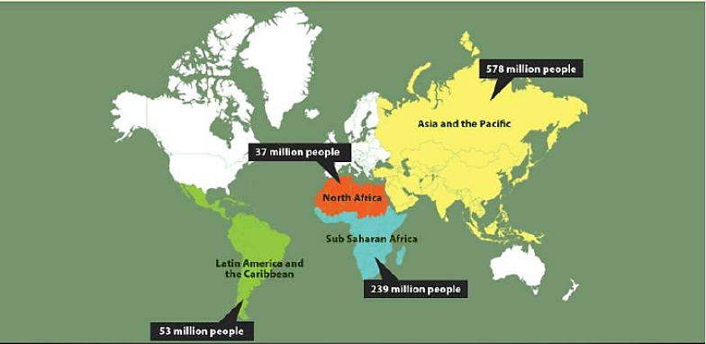

**Is population Explosion to blame?**

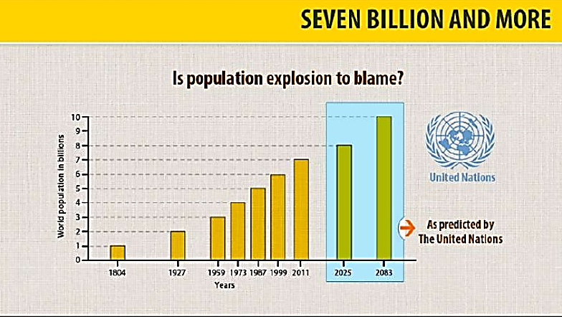

* As the world is suffering from one of the disastrous pandemic in the human civilization i.e. N-COV II and in the time of this crisis we thought of providing food to the needy ones such as the migrant laborer and day workers who do not have enough resources to feed themselves and their family.

**REFRENCES**

* [**https://www.javatpoint.com/**](https://www.javatpoint.com/)
* [**http://stackoverflow.com/**](http://stackoverflow.com/)
* [**https://www.feedingindia.org**](https://www.feedingindia.org)
* [**https://www.w3schools.com**](https://www.w3schools.com)
* [**https://www.php.net/**](https://www.php.net/)
* [**https://getbootstrap.com/**](https://getbootstrap.com/)
* [**https://fontawesome.com/**](https://fontawesome.com/)

**User Manual**

User manual or user guide to is to help our users to go through the website and refer to the manual if he/she faces any problems and glitches. This manual is designed to help our end users.

**Content:**

1.Creating an Account

2.Login

3.Donate Food

4.Donate Money

5.Request for Food

6.Volunteer

7.About Us

8.Profile

9.Update Info

10.Signout

Note: - For visuals do refer to the snaps given in the section ‘module wise snaps’.

**1.Creating an Account:**

Here, the user has to provide personal details such as name, gender, role contact details, email, username and password. After giving all these details the account will be created.

* Click on the link given in top right corner of the website Create an Account.
* Fill up the details.
* Click on submit button.

**2.Login:**

Here, the same username and password will be used that we had provided during registration to login into the system.

* Click on the link given in top right corner of the website sign in.
* Fill up the details.
* Click on submit you will be directed to home page.

**3.Donate Food:**

Here, you have to first provide the detail of the type of food which you want to donate, whether raw food or prepared. After selecting that you have to provide the address of yours where you want our volunteers to reach you and collect food after quality checking.

* Login into the website
* Click on the Donate food section in the home page.
* Fill up the type of food you want to request.
* Fill up the address details.
* Click on the submit button.

**4.Donate Money:**

This is the module where you don’t have to register first, you can donate the food without registering by providing basic details such as email, phone no and amount.

* In the home go to the donate money section.
* Just fill up the details.
* Directed to the payment portal.
* Fill the card details.
* Click on to submit.

**5.Request for Food:**

Here, needy people can register into our website and request for food that he need. He has to provide the address details where he want the food to be delivered.

* Login into the website
* Click on the request for food section in the home page.
* Fill up the type of food you want to request.
* Fill up the address details.
* Click on the submit button.

**6.Volunteer:**

Here, any user can volunteer in our programme by just registering into our website and providing the time slot according to his/her convenience.

* Register as volunteer while registering into the website.
* In the menu of the website go the volunteer section.
* Fill in all the required details.
* Just click on submit button.

**7.Contact Us:**

Here, you will get more info about our programme.

You can connect via Facebook, twitter and Instagram and you can easily find that in footer section of our website.

**8.Profile:**

Any user can see his/her profile by just clicking on the profile section after login into our website.

* To see your profile just go on to the top right corner of the website and click the profile link.

**9. Update Info:**

Here, a login user can update his/her address info.

To update the address info:

* Go to the top right corner of the website you can see the link of the profile just click on it.
* Down below of your profile you can see the address details just update the info.
* Click on the button to get the address updated.

**10.Signout:**

By clicking on signout, the user can signout from our website.

* For signout go to the top right corner and click on the signout link you will be redirected to the home page of the website.

**Developer Manual**

Developer manual or developer guide is to help developers who want to further develop this project. There are following steps need to be followed before proceeding further.

Prerequisites: Thorough understanding of high-level languages HTML, JavaScript, jQuery and CSS for frontend development and PHP and MySQL for backend development. We have used Xampp server as a local web server.

For developing the project and working on the project on localhost, a developer should follow these steps.

* First of all download and setup Xampp on your system through <https://apachefriends.org> link. If you have already then please ignore this.
* Download the source code attached with this documentation file.
* Place this code inside this folder path: (C:\xampp\htdocs).
* Create database by creating tables as mentioned above at page no. 10 and follow these steps
* First Open Xampp. A window will appear on your screen as shown below:

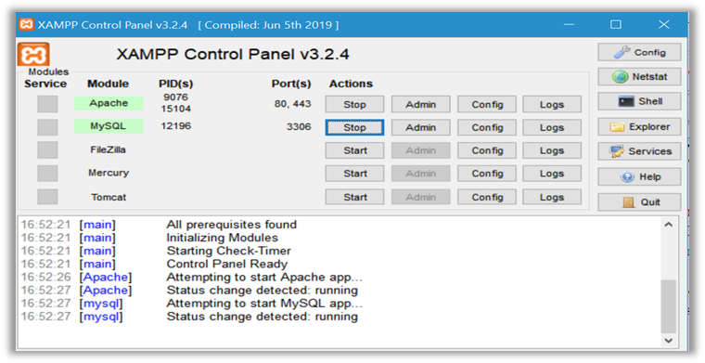

* Start Apache and MySQL. Then minimize this window and open we browser.
* Type localhost into the URL section of any web browser (we prefer Google chrome). Xampp dashboard window will open as shown below.

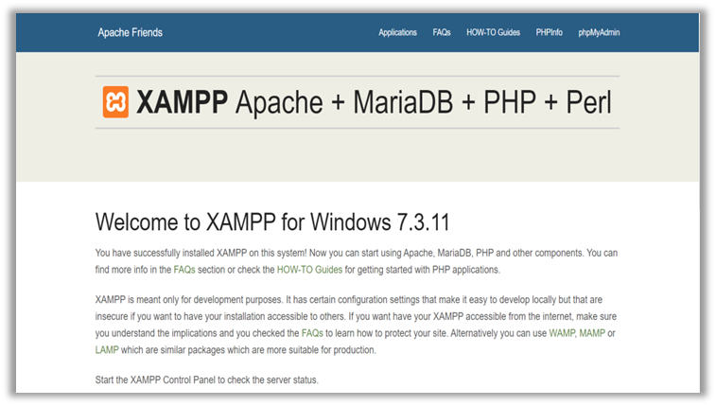

* Click on phpMyAdmin (as outlined in above image). You will see a window like this:

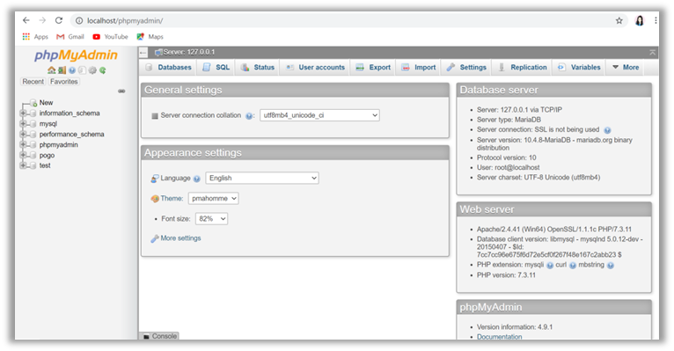

* After that a developer can create database and tables according to his/her requirements.
* For creating the names of the variables and functions or the table names use Pascal casing.
* To modify the code just open the desired file with any text editor (recommended: visual code) and modify it.

To run the Project, please follow these steps systematically.

* Open Xampp. A control box will appear.
* Start Apache and MySQL. Then minimize it.
* Open any web browser (recommended: Google Chrome)
* Type localhost/alleviatehunger/index.php into the URL section of the browser.
* Here, a home page will appear.